I have been influenced by both professional artists and by outsider art as well as the work made by people who do not always define themselves as artists but feel compelled to create, to reuse and redefine materials. I am interested by this transformation whether it is an armadillo made into a basket, popsicle stick lamp or rug made with pastic bags. Below are some of my interests and influences.
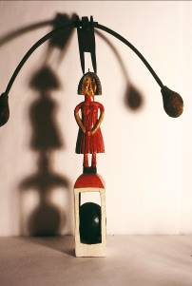
This images has two carving that I bought in Pennsylvania. The figure in the red dress is intended to demonstrated the woodcarver’s expertise. The sphere inside the white 4 column area was carved away from a solid bottom. The carver removed the wood to create a ball trapped by the 4 columns. The piece on top is from a balancing toy. I used this as a prop in the drawing balancing act. Both pieces represent skill and whimsey to me.

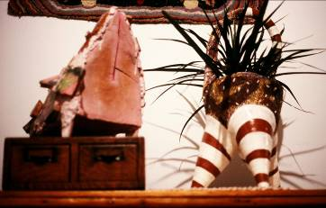
The piece on the left is a ceramic sculpture by Terry Johnson, an artist who lives in Lemont Pennsylavania. It’s pink cement and has large chinck of blue, pink and white cermaic adherred to the sides in a mosaic like pattern. It struck me as aggressive and girly and on the move. The piece on the right is by a cermaic artist Karen York who went to grad school at Penn State. I liked the sturdiness of the piece and I thought it also looked like it was on the move. I have made a few pieces with legs that I am sure were influenced by these works ( birdhouse titled Protected Space and a sculptural heart titled On the Move).
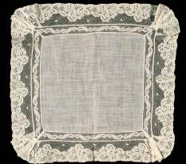
This is a hankerchief that I inherited from my mother. I love the delicacy and the fan like shapes at the corners. It reminded me of many textiles and quilts that have been an influence. I studied with Miriram Schapiro in graduate school and her love of textiles was a strong influence on me.
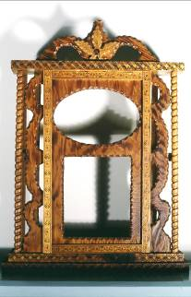
This is a frame for a clock- goes in bottom section and top is for a photo. The piece is by Howard Finster. I have admired his prints and love the repetition and pattern in this piece. I visited Paradise Garden where Finster had created amazing outbuildings made from bicycle parts, walls and concrete paths filled with mosaic, tin foil iscicles hanging from buildings – a magical amazing place.
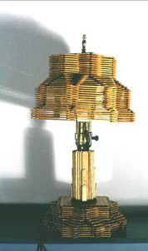
What’s not to love about popsicle stick lamps? The obssesiveness, the patterns created by how the sticks intersect, the quirkiness and just that transformation of such a common ordinary material into a decorative object.
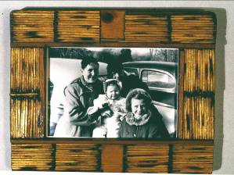
Yes I am the baby in the center… and the rest of the folks are my brohters and sister. The frame is made of matchsticks and again it is the transformation of a simple material into a completely new object that I find inspiring.

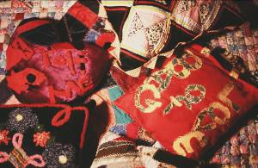
I have always loved textiles and have collected qulits, pillows etc. The pillow on the right says Bag of Love and the purple and red pillow on the upper left says Catch Me. They both have cloth handles sewn on them. The pillows were made by a homeless woman in San Franscisco who used to stop by art classes taught by Monica Armstrong. The woman who made the pillows said she made them with handles so she could carry them easily. I was very moved by the fact that she felt compelled to created objects that clealry had personal significance for her and that she was so practical and straightforward to add handles.

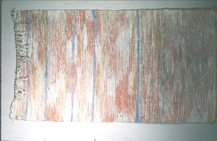
This is a rug I bought when I lived near Penn State. The farmer that sold it to me said he had a planting, harvesting and in the winter a rugmaking season. He made the rug from wonder bread wrappers. Again it’s the transformation of an ordinary material giving it a new use and meaning.

